October is national
Domestic Violence Awareness Month
please support
PURPLE LIGHT NIGHTS ™

Let a light shine on your porch or business from
October 1-31st to:
- Remember those who lost their lives
- Support the survivors
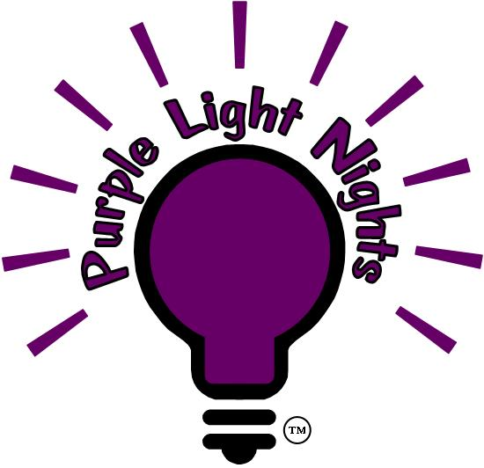
- Bring hope to those still abused

“Domestic Violence Has NO Place
in Our Community”

Lights available at Covington City Hall
call Victoria 253-638-1110 x2237 - email: pln@ci.covington.wa.us
Proceeds benefit the Covington DVTF.

