October is national
Domestic Violence Awareness Month
please support
PURPLE LIGHT NIGHTS ®

Let a light shine on your porch or business from
October 1-31st to:
- Remember those who lost their lives
- Support the survivors
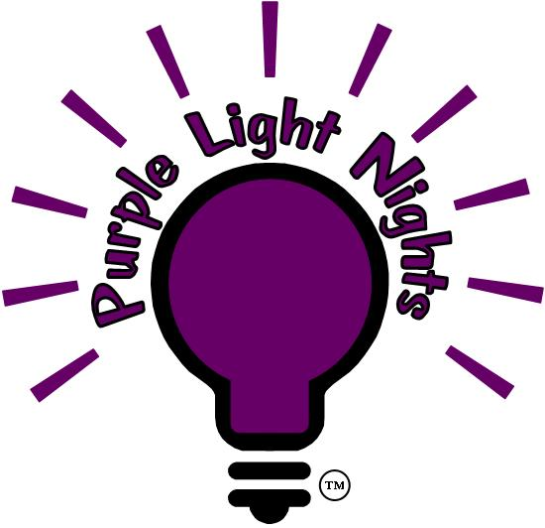
- Bring hope to those still abused
$3.00 each
two for $5.00

Light strings:
$30.00

Tree Sponsor $100.00

Lights available at Covington City Hall or call:
Victoria 253-638-1110 x2237 - email: pln@ci.covington.wa.us
Proceeds benefit the Covington DVTF.

