Covington City Hall - 16720 SE 271st Street, Suite 100, Covington, WA 98042
Phone: 253-638-1110 x2237 Fax: 253-638-1122
Web site: www.purplelightnights.org
Email: pln@ci.covington.wa.us

DATE
RE: PURPLE LIGHT NIGHTS® CAMPAIGN

Dear Business Owner and Community Partner,

Each year, businesses suffer a loss of productivity and earnings due to intimate partner violence that accounts for almost $1.8 billion annually. In 2006 alone, Washington State had 49,980 reported cases of domestic violence. In the past ten years, 359 people in Washington were murdered by their abuser. The Covington Domestic Violence Task Force (CDVTF) is actively working in our community to heighten awareness and support victims of domestic violence. We are asking that you help honor those who have lost their lives and send the strong message that “Domestic Violence Has No Place in Our Community”.

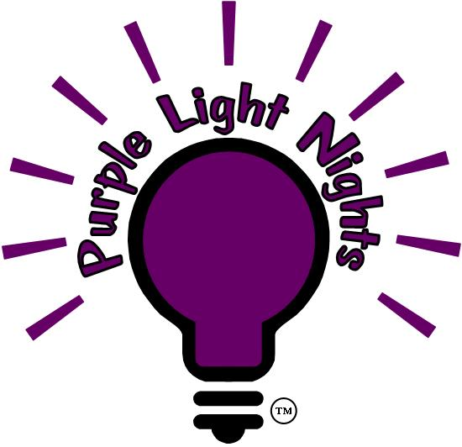
Congress has proclaimed October as the National Domestic Violence Awareness Month. The CDVTF holds a Purple Light Nights® campaign during the month of October. This national awareness campaign involves residents shining a purple light bulb on their front porch or front window for the entire month to remember the victims and honor the survivors of domestic violence. Last year we increased the campaign to include businesses that sponsored lighting the street trees in Covington Place. Due to the success of the campaign the number of possible sponsorships is being increased for this year. Local businesses may participate in the following two ways:

Covington Domestic Violence Task Force
TIME SENSITIVE
INFORMATION
Reply by Sept. 15TH
“The Purple Light Nights® campaign is a terrific way to bring attention to the devastating impact that domestic violence has on families and children. I want to encourage every citizen of our state to take a few minutes this October to affix a purple light to their home or workplace to shine more light on the need to stop domestic violence.”
~ Washington State Attorney General Rob McKenna
Sponsor lighting a city street tree with purple lights (price includes lights and installation of one street tree). Sponsorships will be allocated in the order they are received as each location is filled: (A recognition sign noting your business will be posted at the tree. In addition your name will also appear in the October Covington Update issue of the Covington Reporter.)
$30

$100

- Purchase a single string of purple lights to place in your own business window.
(Your business name will appear in the October Covington Update issue of the
Covington Reporter.)

All proceeds benefit the CDVTF, a non-profit organization, so your donation is tax deductible. Donations have provided food, gas cards, and motel vouchers for 92 bed nights, keeping many women and children safe. To order your lights please complete the enclosed form, mail or fax today and make a difference in someone’s life.

Sincerely,

Victoria Throm
President, CDVTF

